

Database Management Lab Sheet (ENCS205)
Bachelor of Technology in
Computer Science and Engineering

Submitted by
Sahdev Sharma (2401010092)
B. Tech CSE (Core) – 4th Semester Section: A

Submitted To:
MS. Mansi Kajal

School of Engineering & Technology
K. R. MANGALAM UNIVERSITY
Sohna, Haryana 122103, India feb-2026

Experiment- 5
(Exercise on retrieving records from the table)
EMPLOYEES (Employee_Id, First_Name, Last_Name, Email, Phone_Number, Hire_Date, Job_Id, Salary, Commission_Act, Manager_Id, Department_Id)
( a) Find out the employee id, names, salaries of all the employees . ( b) List out the employees who works under manager 100 .
( c) Find the names of the employees who have a salary greater than or equal to 4800 . ( d) List out the employees whose last name is ‘SINGH’ .
( e) Find the names of the employees who works in departments 60,70 and 80 . ( f ) Display the unique Manager_Id.

[Query] :
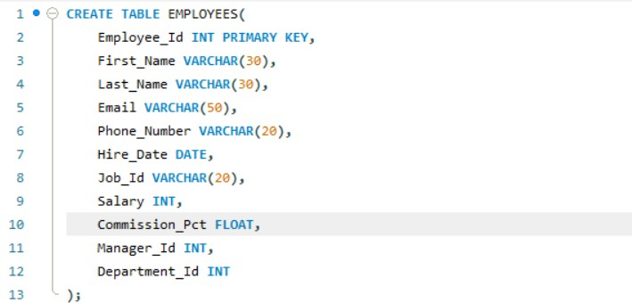

[Data] :
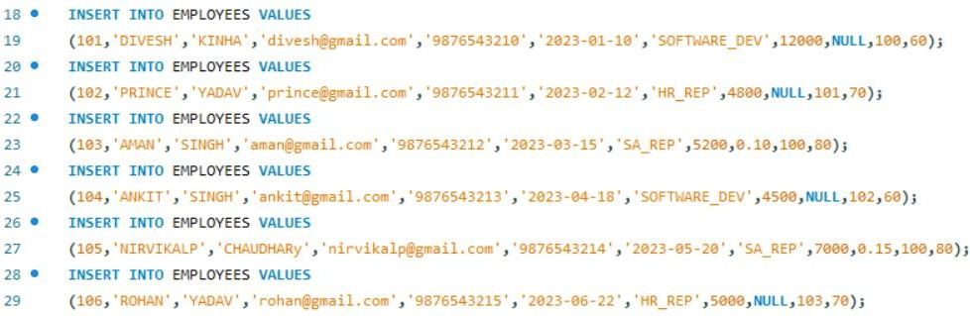

( a) Find out the employee id, names, salaries of all the employees .
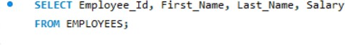
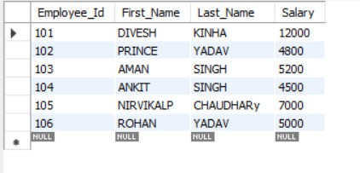

( b) List out the employees who works under manager 100 .
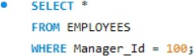
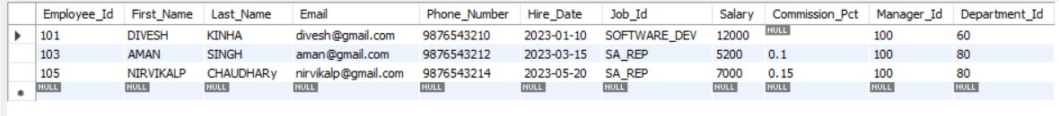

( c) Find the names of the employees who have a salary greater than or equal to 4800 .
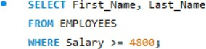
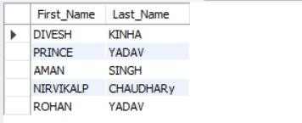

( d) List out the employees whose last name is ‘SINGH’ .
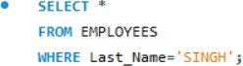
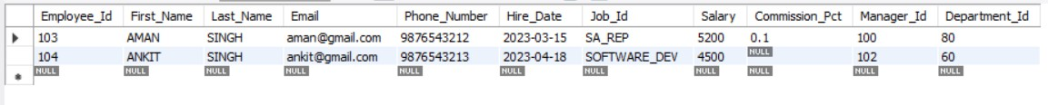

( e) Find the names of the employees who works in departments 60,70 and 80 .
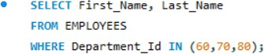
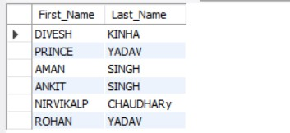

( f ) Display the unique Manager_Id.

